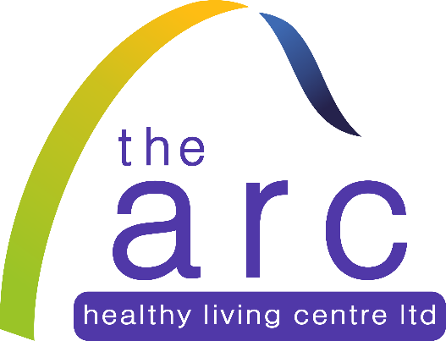

FOOD BANK
Fridays 1 – 2 pm

116-122 Sallyswood
Irvinestown

