WARM WELCOME DAYS

IN THE ARC HEALTHY LIVING CENTRE

MONDAY TO FRIDAY 9 a.m. to 3 p.m.
A warm welcome awaits
Free tea / coffee / WiFi and a chat!

ARC HEALTHY LIVING CENTRE

116-122 Sallyswood, Irvinestown,

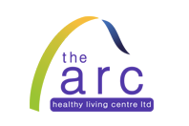
BT941HQ tel 028 686 28741

