**Health Promoting Homes**

**Starting Wednesday 10th January at ARC Healthy Living Centre**

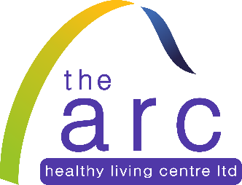

***Cooking & Nutrition***

***Personal Development***

[](http://www.google.co.uk/url?sa=i&rct=j&q=&esrc=s&source=images&cd=&cad=rja&uact=8&ved=0ahUKEwil57uuuLfRAhUDnRQKHbpTDeQQjRwIBw&url=http://www.bhru.iph.cam.ac.uk/research/physical-activity/&psig=AFQjCNEG0WQ7J-8n_Gm3rwU_RXMlYKlJLA&ust=1484132953873667)

[](http://www.google.co.uk/url?sa=i&rct=j&q=&esrc=s&source=images&cd=&cad=rja&uact=8&ved=0ahUKEwj6hP6AtPXXAhVInBoKHeUgCp8QjRwIBw&url=http://danrossmotivation.co.uk/personal-development/&psig=AOvVaw3o8Gh1u6sCZgfoxkjf8kGF&ust=1512650331473915)

***Physical Activity***



There will be incentives & gifts at the end of the programme for participants who complete the programme.

Limited places, to reserve a place contact the ARC on 02868628741 or email [anne.taggart@archlc.com](mailto:anne.taggart@archlc.com)

Programme starting Wednesday 10th January 2018 10am at ARC HLC, Irvinestown.

*Supported by*