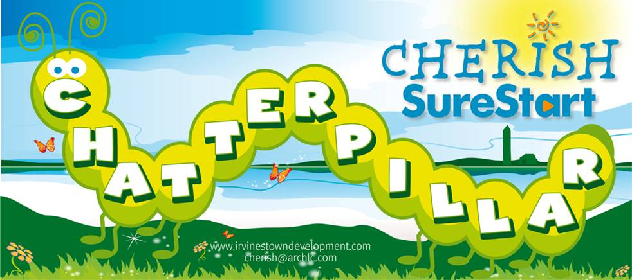SUMMER PROGRAMMES 2017

Trip to Castle Adventure Fun Farm in Ballyshannon

5th July 9.30am pick up at ARC Healthy Living Centre, Sallyswood

. Please bring a picnic.

Cost per Adult £6

Children over 2’s £6

[](https://previews.123rf.com/images/tigatelu/tigatelu1509/tigatelu150900539/45168921-Cartoon-Happy-cartoon-cow-Stock-Vector-farm.jpg)

**DON’T FORGET** Seats for all bus trips are only secured on receipt of payment. Please ring the office to book place on 686 21970

**Please remember wear suitable clothing & sun cream**

**Trip to** 

**25th July -** 9.15am pick up at Roslea Community Centre and 10.00am at the Courthouse Newtownbutler.

2 hours play with Food & Drink €8 per head

2 hours play with Drink only €5 per head

**DON’T FORGET** Seats for all bus trips are only secured on receipt of payment. Please ring the office to book place on 67738063

Trip to Belfast Zoo

23rd August

[](https://previews.123rf.com/images/clairev/clairev1201/clairev120100050/11918017-Zoo-sign-with-various-animals-vector-illustration--Stock-Vector.jpg)

9.00am pick up at ARC Healthy Living Centre, Sallyswood entrance and at 9.30am Rooney’s Spar Shop, Kilmacormick. Please bring a picnic.

Cost per Adult £11.50

Children over 4’s £6

**DON’T FORGET** Seats for all bus trips are only secured on receipt of payment. Please ring the office to book place on 686 21970

**Please remember wear suitable clothing & sun cream**

**Mermaids and Pirates**

**Fun Day**

[](http://www.google.co.uk/url?sa=i&rct=j&q=&esrc=s&source=images&cd=&cad=rja&uact=8&ved=0ahUKEwjY_7yIkcLUAhWJ1xQKHVSbAnEQjRwIBw&url=http://worldartsme.com/mermaid-and-pirate-clipart.html&psig=AFQjCNEOBOPiZ34ahmQG2Mf5QeklwmPxrw&ust=1497694463344274)

29th August at 10am in the ARC Healthy Living Centre

Come along and join in our

Arrrrrrrrt & activities!

Treasure Hunt

Water & Sand Play

Face Painting

And much more……

**Stay & Play groups re-open**

**week starting 4th September**

[](http://www.google.co.uk/url?sa=i&rct=j&q=&esrc=s&source=images&cd=&cad=rja&uact=8&ved=0ahUKEwialuS1lcLUAhVHvxQKHb6zCjgQjRwIBw&url=http://www.testdafbeograd.com/default.php?nIdItem%3D8&psig=AFQjCNG88DgJm5woUkijx-wBP_AsdMUZKg&ust=1497695648234150) **Keep up to date with programmes on our Cherish Sure Start Facebook Page and website: www.archlc.com**

Join Cherish Sure Start face book page to get up to

**Stay & Play Groups**

**Re-open**

**Week beginning 4th September**

**What’s on Diary ….**

|  |  |  |  |  |
| --- | --- | --- | --- | --- |
| **MONDAY** | **Where** | **Start Date** | **Time** | **Weeks** |
| One stop Baby Shop  (Local Health Visitor Drop in Clinic) | ARC Healthy Living Centre, Irvinestown | On going | 1.30pm-3pm | 2nd & 4th Week of every month |
| Breast Friends | ARC Healthy Living Centre, Irvinestown | On going | 1.30pm-3pm | weekly |
| Buggy Fit | Meet at Necarne Car Park | 3rd July | 10am-11.30am | 5 |
| Music Day | Old Courthouse, Newtownbutler | 3rd July | 11am-12pm | 1 |
| Tiny Talkers | ARC Healthy Living Centre, Irvinestown | 10th July | 11am – 12pm | 4 |
| Music Day | Community Centre, Roslea | 10th July | 11am-12pm | 1 |
| Nature Walk | Devenish Partnership | 7th Aug | 10am-11am | 1 |
| Rhyme Time | Irvinestown, library | 7th Aug | 10.30am-11.30am | 3 |
| Cooking Day/ Teddy Bears Picnic | Old Courthouse, Newtownbutler | 14th Aug | 11am-12pm | 1 |
| Treasure Hunt | Devenish Partnership | 14th Aug | 10am-11am | 1 |
| Teddy Bears Picnic | Round O’, Enniskillen | 21st Aug | 10am-12pm | 1 |
| Cooking Day/ Teddy Bears Picnic | Community Centre, Roslea | 21stAug | 11am-12pm | 1 |

|  |  |  |  |  |
| --- | --- | --- | --- | --- |
| **TUESDAY** | **Where** | **Start Date** | **Time** | **Weeks** |
| Nearby Nature | Castle Archdale Court Yard | 11th July | 10.30am-12.30pm | 2 |
| Tiny Talkers | Aisling Centre, Enniskillen | 11th July | 11am-12pm | 4 |
| Teddy Bear Picnic | Meet at Trillick Leisure Centre | 18th July | 10am-12pm | 1 |
| Treasure Hunt | Meet at Muckross Car Park, Kesh | 25th July | 10am-11.30am | 1 |
| Tickle Tummy | ARC Healthy Living Centre, Irvinestown | 1st Aug | 10am-11am | 4 |
| Nearby Nature | Castle Archdale Court Yard | 8th Aug | 10.30am-12.30pm | 3 |

|  |  |  |  |  |
| --- | --- | --- | --- | --- |
| **WEDNESDAY** | **Where** | **Start Date** | **Time** | **Weeks** |
| Boogie Beats | Scout Hall Enniskillen | 19th,July | 10am-11am | 2 |
| Big Cook Little Cook | ARC Healthy Living Centre, Irvinestown | 19TH July | 11am-12.30pm | 2 |
| Physical Day | Old Courthouse, Newtownbutler | 19th July | 11am-12pm | 1 |
| Boogie Beats | Old Courthouse, Newtownbutler | 19th July | 11am-12pm | 2 |
| Physical Day | Community Centre, Roslea | 26th July | 11am-12pm | 1 |
| Boogie Beats | ARC Healthy Living Centre, Irvinestown | 2nd Aug | 10-11am | 4 |
| Infant Massage | Old Courthouse, Newtownbutler | 3rd Aug | 10-11am | 5 |
| Boogie Beats | Old Courthouse, Newtownbutler | 9th Aug | 11am-12pm | 2 |

|  |  |  |  |  |
| --- | --- | --- | --- | --- |
| **THURSDAY** | **Where** | **Start Date** | **Time** | **Weeks** |
| Tumbling Tots | Scouts Hall Enniskillen | 6th July | 10am-11am | 4 |
| Messy Play | Tullynagarn, Irvinestown | 6th July | 10.30am-11.30am | 1 |
| Infant massage | ARC Healthy Living Centre, Irvinestown | 6th July | 11am-12noon | 4 |
| Sensory Play | Old Courthouse, Newtownbutler | 6th July | 11am-12pm | 4 |
| Boogie Beats | ARC Healthy Living Centre, Irvinestown | 6th July | 2.30pm-3.30pm | 4 |
| Mum & Baby Yoga | Old Courthouse, Newtownbutler | 6th July | 11am-12pm | 4 |
| Bug Hunt | Castle Archdale Court Yard | 13th July | 10.30am-11.30am | 1 |
| Teddy Bears Picnic | Castle Archdale Court Yard | 20th July | 10.30am-11.30am | 1 |
| Sensory Play | Tullyngarn, Irvinestown | 10TH Aug | 10.30am-11.30am | 1 |
| Solid Start | ARC Healthy Living Centre, Irvinestown | 10th Aug | 11am-1pm | 4 |
| Boogie Beats | Community Centre, Roslea | 10th Aug | 11am-12pm | 4 |
| Tumbling Toddlers  (age 2-4years) | Old Courthouse, Newtownbutler | 17th Aug | 11am-12pm | 4 |
| Making Music | Tullynagarn | 24th Aug | 10.30am-11.30am | 1 |

|  |  |  |  |  |
| --- | --- | --- | --- | --- |
| **FRIDAY** | **Where** | **Start Date** | **Time** | **Weeks** |
| Toddler Yoga | ARC Healthy Living Centre, Irvinestown | 7th July | 10.30am-11.30am | 3 |
| Crafty Rhymes | Old Courthouse, Newtownbutler | 7th July | 11am-12pm | 4 |
| Crafty Rhymes | Community Centre, Roslea | 7th July | 11am-12pm | 4 |
| Stay & play | Tullynagarn, Irvinestown | 7th July | 10.30am-12pm | Weekly |
| Stay & Play | Devenish | 7th July | 10.30-12pm | 4 |
| Toddler Yoga | ARC Healthy Living Centre, Irvinestown | 11thAug | 2pm-3pm | 3 |
| Bug Hunt | Devenish Partnership | 11th Aug | 2-3pm | 1 |
| Baby Peep | Community Centre, Roslea | 11th Aug | 11am-12pm | 4 |

[](http://www.google.co.uk/url?sa=i&rct=j&q=&esrc=s&source=images&cd=&cad=rja&uact=8&ved=0ahUKEwjVieaZlcLUAhVJkRQKHTIWAqEQjRwIBw&url=http://www.symbols.com/symbol/facebook-logo&psig=AFQjCNE6pp6DO_Ga52-wUPQAsfS7njSpcw&ust=1497695647826457)

**We are now taking bookings for our Evening Nurturing Programme commencing Tuesday 12th Sept from 7pm-9pm in the ARC Healthy Living Centre**

Irvinestown Office -Head Office

The ARC Healthy Living Centre,

60 Castle Street Irvinestown

Co Fermanagh BT94 1EE

Telephone 028 686 21970

Email: Cherish@archlc.com

Newtownbutler Office - Sub Office

The Old Court House, Bridge Street, Newtownbutler,

Co Fermanagh BT92 8EN,

Telephone 028 67738063/ 67738086 Email: Cherish@archlc.com

**6**